Firmware Upgrade Phishing Testing Lab (Wifiphisher)
Complete Guide
Prerequisites
- Operating System: Kali Linux
- Tools: Wifiphisher installed
- Hardware: Wireless adapter capable of both Monitor Mode and Access Point (AP) mode.

Step 1: Launching Wifiphisher and Selecting the WiFi
- Open your terminal.
- Run the Wifiphisher command: sudo wifiphisher
- Wait for the scanning process to finish and the list of nearby networks to populate.
- Use the Up and Down arrow keys to highlight the target network (in this lab, lab test wifi).
- Press Enter to select the target.
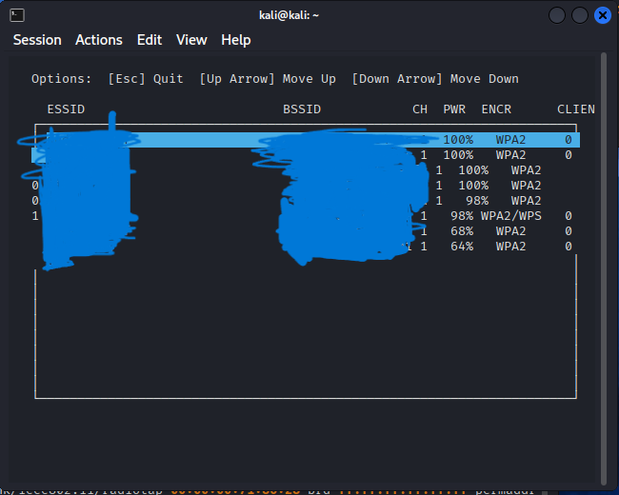

Step 2: Selecting the Firmware Upgrade Scenario
- After selecting the target, Wifiphisher will present a menu of phishing scenarios.
- Use the arrow keys to navigate and select Option 3: Firmware Upgrade.
- Press Enter.
- Wifiphisher will now automatically create an "Evil Twin" access point (copying the exact SSID of the target) and will begin sending deauthentication packets to disconnect the victim from the real network, forcing them to join the fake one.
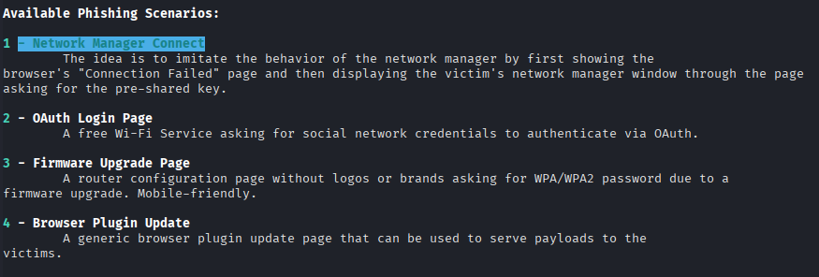

Step 3: The Victim's Perspective (Firmware Upgrade Prompt)
- The victim's device (in this test, an iOS device) automatically tries to reach captive.apple.com to check for internet.
- Wifiphisher intercepts this request and serves a fake captive portal page.
- The victim is presented with a page titled "Firmware Upgrade". It displays a fake version (1.0.12) and Terms and Conditions from "Unknown" (2026).
- The victim is instructed to enter their WPA2/WPA3 Pre-Shared Key into the field and click Start Upgrade before they can use the network.
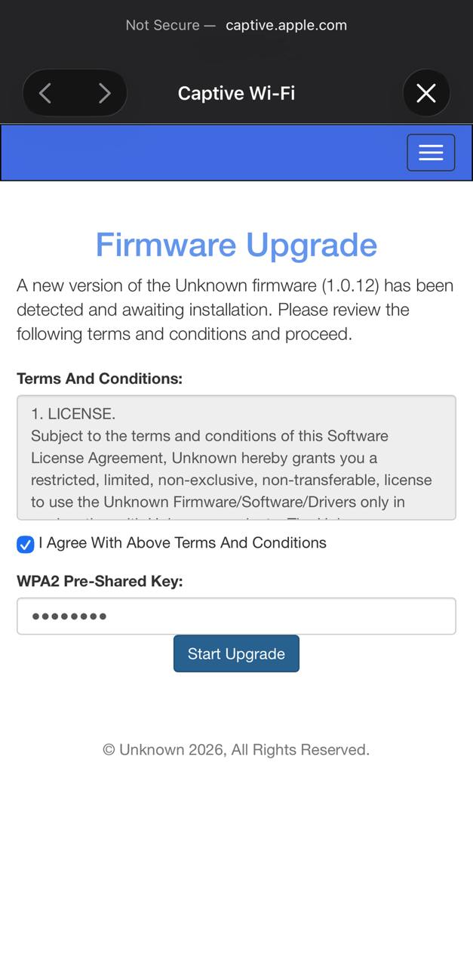
Step 4: Password Phished via Victim Entering
- The victim enters their password (e.g., Password0) and clicks Start Upgrade.
- The data is sent via an unencrypted HTTP POST request to the attacker's server.
- Back in the attacker's terminal (Kali), Wifiphisher captures the request.
- In the terminal output, you will see the captured credentials:
POST request from 10.0.0.87 with wifiphisher-wpa-password=Passw0rd
- The WPA2 password has been successfully phished. (Passw0rd)
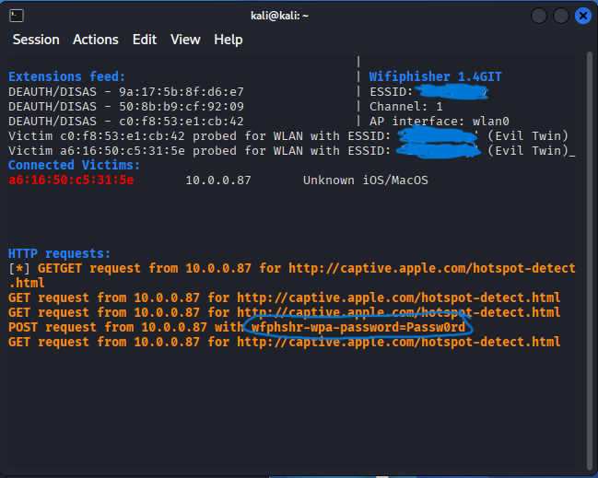

⚠️ Important Disclaimer
This testing guide is strictly for educational and authorized penetration testing purposes only. You must have explicit written permission from the network owner to test this. Unauthorized use is illegal.

